Challenges facing the Next United States President

Student Name
Institution
Course name
Instructor Name
Due Date

Introduction
The United States is a superpower country in the world, also faces some difficult moments. The year 2020, to be precise, has had its fair share of challenges. It was also their election year with the presidential candidate Joe Biden against Donald Trump for the forty-sixth president. The global Corona Virus pandemic, which set its ugly reality in December of 2019, has unleashed its wrath on the US. Over fifteen million positive infections are reported, over two hundred thousand deaths, and tens of thousands of new cases ongoing (Brinks & Ibert, 2020). The country has also suffered natural disasters such as the Atlantic hurricane and raging wildfires in California that have burnt 3.7 acres of land. These immense catastrophes have taken a toll on the nation's economy, with over thirty million out of work. They have also burdened the nation's infrastructure, health system, and educational institutions nationwide. Regardless of who takes the win, they will face the burden of managing the current situation and strive to drive the nation to a more stable position. It will be policymakers' role in their administrations to help develop reforms that will rescue the ailing economy and help with the fight against the pandemic. In what follows, I will explore public policy issues that represent an inadequacy in current government policy, identify the underlying problem, propose reforms and give my recommendations to the next president on what action to prioritize in their first six months in office.
The Global Pandemic and natural disasters
The coronavirus pandemic has wreaked havoc across the world, destroying livelihoods and, worse, causing many deaths. The United States was worst hit by this pandemic, which seems to worsen by the day. It has created both a public health crisis and an economic crisis in the nation. Since the virus broke into the country, the current President, Donald Trump, always downplayed the spike's severity in positive cases and reported deaths. He chose to polish the forecasts and the vaccine development timelines even when medical experts disagreed with his perspective. President Trump went as far as mocking the wearing of masks, which was the first line of defense against the virus, and even he did not wear a mask at any point. The hospital systems filled beyond capacity, which in turn created a global economic slowdown. During the presidential campaigns, Trump's stand took a toll on his popularity since most people disagreed with his influence on the citizens.
Natural disasters, hurricanes, and wildfires have caused economic and health issues among the affected areas. The administration should implement Reforms through the Disaster Management Act of 2016 to set aside emergency funds to cater to relocation and upkeep of the people living in disaster-prone areas (Comfort, 2005). The administration should also ensure frequent health evaluations on the people and the environment to mitigate the health effects caused by the occurrences, such as poisonous emissions from wildfires.
The affordable care Act
The Affordable care Act that got introduced in the previous tenure of president Barrack Obama had a substantial effect on the United States health care system. The Act focused on the affordability of health services and consolidation with insurance companies to make accessible to as many citizens as possible without compromising the quality of services (McElfish et al., 2015). However, some policies still hinder adequate health services provision.
Firstly, government policies have reduced completion by limiting the available supply of health services providers and restricting the range of services offered. Such action inhibits innovation, slows finding ways to provide more cost-effective medical assistance, and reduces medical options, hence no competition. The government should streamline funding for graduate medical education to increase the available workforce and help cope with physician supply and medical services demands. It will also reduce unhealthy competition that leads to high medical care charges, diminishing incentives to improve quality.
Secondly, the insurance industry's lack of policies that regulate the amounts of premiums charged on medical covers reduces choice for consumers and competition. The insurance companies also offer limited coverage option, which does not align with the customers' needs. In some circumstances, certain medical conditions that clients would prefer to be covered by their insurance are not even available for choice, and they instead offer services that the consumers do not need or want. When faced with such medical issues, they end up paying off their pockets, claiming to be covered by insurance. The government should abolish policies that limit the choice of options for cover and encourage them to develop a body regulating the insurance companies to have them offer a wide range of customer preference services. There can also be reforms to scale back on government restrictions that will reduce competition barriers and offer the customers unlimited opportunities to the health insurance package that meet their needs.
Thirdly, policies; whereby payment towards medical care and services rely on third parties leave no option over the services and facilities they prefer. Reforms are to be enforced that will consider clients to have more control over their health care spending. It will help them have the chance to choose the level of facilities where their funds can accommodate and bear power regarding the quality of medical services and thereby get value for their money. Accessing Health Savings Accounts will promote choice in preference over the price and quality transparency and enable customers to make informed medical care decisions. Encouraging value-based payment structures to incorporate flexibility and avoid undue burden upon small and rural practices. Incorporating telehealth services will improve the accessibility of medical practitioners to patients by improving workforce mobility.
Lastly, state policies that restrict entry into health provider markets and suppressing entry into certain medical advances immobilize initiative and create unnecessary demand for health care services. Reforms that should be implemented will offer encouraging incentives and allow for new ideas and technology to improve the quality of services.
Effects of the Corona Virus pandemic on the economy
Global growth was already on the low, and the coronavirus pandemic's emergence only made it worse. The United States economy has been hit hard by the challenges that have occurred in the recent past. It is an obvious observation that pandemic poses a tremendous risk to the US economy. The economy was mostly affected by the virus's mitigation measures that saw countries and cities being locked down for weeks at a time. These measures were to help reduce contact with people since it's the primary way through which the virus is transmitted. This meant that companies and individual local businesses, as well as educational institutions, remained closed.
The major setback against the economy is the disruption of the global supply of goods. Companies found it hard to fill orders for imports and supply for exports. This shortage, in turn, led to reduced incomes caused by less demand that affects business investments. The uncertainty around the pandemic's future regarding finding vaccines or timelines about when it will be under control made it hard to make plans for the future for small businesses to even the nation. The unpredictable future increased volatility in the financial markets. Another challenge is with the international investors who cannot calculate the risk while seeking to invest in the affected countries and have, therefore, held back to speculate before making any decisions. Prices on bonds are given a range for their maturity, reflecting an increased possibility of a recession. Such moves are a vivid sign of worry in the financial markets regarding the economy's future outlook
.
Figure 1
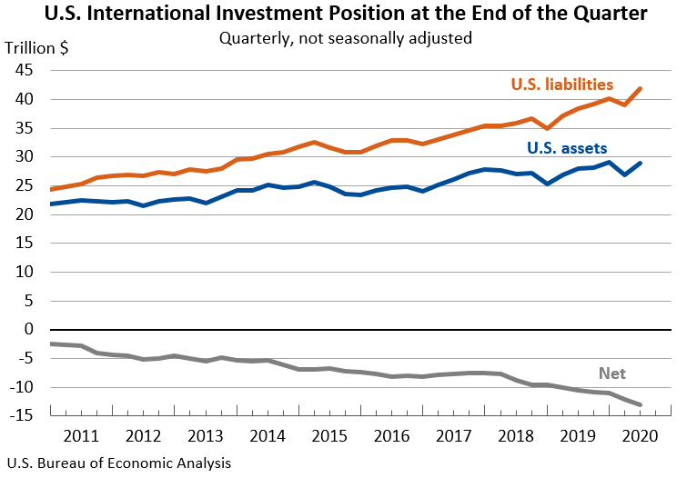
China, which is the largest contributor in the supply chain to the US, had its factories located in the affected areas shut down. It caused a sudden shock in the supply projections, and the countries in the US were forced to find alternative suppliers to source the goods from other parts of the world to sustain and manage the demand. Reforms in the US will need to be put in place to help tighten their supply chains to manage the time between importing from china. When they can put them in their local production, the situation will reduce the nation's economic activity and, by effect, growth.
Current policies to help cushion the citizens from the pandemic effects included offering low-interest rates, which did not provide much assistance for long-term solutions since the rates were already on the low. Lowering them would become counter-productive for financial institutions, and the central banks in most countries did not offer any lower rates. Reforms are to be put in place to provide aid for the long term, such as the state through the congress should engage in fiscal stimulus and embrace different economic policy action principles in retaliation to coronavirus effects. Among the regulations should be calming financial markets, putting more resources towards public service effort, and easing households and vulnerable populations' risk.
The risk of a disrupted economy can be mitigated even if the pandemic's disastrous effects prove to be complicated. However, there needs to be quick action to manage the US economy and help the nation face a more certain future. Companies, households, and even the government are sinking deeper into debts due to disruption of currency flow. For example, the non-financial corporate debt of national and multi-national companies ranging at ten trillion dollars, which is an upward spike compared to the previous years; besides the pandemic and a weakened economy, the debts need servicing. The fixed costs in the nations leave little money to spend on large debts and accumulated interest rates. There should be efforts to help manage the repayment of debts by either seeking restructuring from the lenders or arranging for waivers on the interests.
Besides significant supply chains, other economic sectors experienced demand declines leading to a substantial reduction in revenues from the shaky economy's overall effect. Citizens have in the recent past thought to reduce the budgets while buying certain commodities which are considered a luxury. This has been mostly influenced by the intention to reduce the risk of contact with the coronavirus. For example, most families have been opting to have their meals prepared at home rather than go out for take-away. Besides reducing the virus's risk while traveling, they have found it more economical and helps save on their money. On this issue, the government encourages the business to come up with home deliveries for essentials such that one would only go out of the house when necessary. This action results in an overall safer nation in the fight against the coronavirus. Still, on the downside, the food industries were negatively affected by slow business leading to reduced profits, incurring losses, and eventually, some opted to close down to avoid further decline. Most people have been encouraged to reduce their spending and instead keep the resources as emergency savings prepared for the uncertain foreseeable future.
The coronavirus pandemic has put the policymakers on the stand and expects them to formulate reforms that will help with the situation to curb the adverse impacts on the economy through quick, effective, and manageable ways. In its policies, the current administration had suggested reducing funding towards the center for disease control and prevention by sixteen percent, emerging and zoonotic infections by twenty-five million dollars, and from the department of health and human services by eighteen million dollars. The latest suggested budget allocation proposal modifies the funding to address the recent disasters, asking for 1.2 billion dollars in an emergency fund for preparedness and response efforts and 1.25 billion dollars for other federal programs. They should also consider workers in employment, individual business owners, and significant sectors since they are interconnected in running a functional economy. They should advocate for programs such as; paid leaves, public health insurance for all, and other social programs.
Unemployment rates
It is a primary duty of a reigning administration to ensure that its population can sustain itself by providing employment. It is, however, a struggle to establish this status even for the United States. The unemployment rates have in the recent past spiked caused by the effects of the global pandemic. This came about as firms were forced to shut down and some to scale down on workers without pay since it all happened unexpectedly, causing sharp declines in revenue stream (Sly & Johnson, 2017). As a result, the population was left with little to spend and sometimes having to squeeze on the basics.

Figure 2
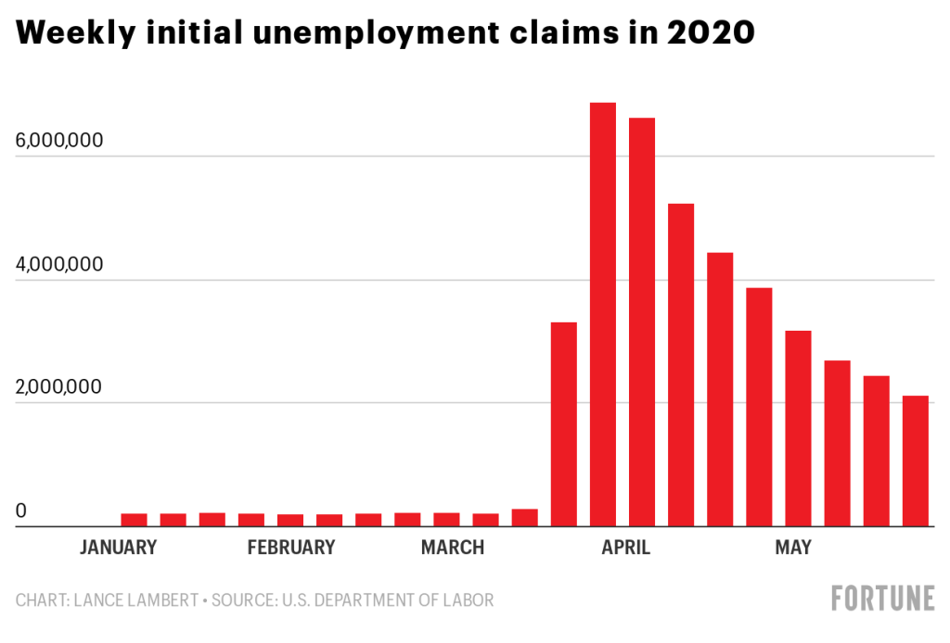
Flight cancellations from China, which was labeled a no-go-zone, meant incurring up to 1.6 million visitors to the United States, which trickled to a loss in projected spending of 10.3 billion dollars. Corporations that relied on Chinese consumers for their luxury goods suffered the most and led to businesses' complete closure. The administration should formulate reforms that encourage the formation of workers associations fighting for their rights and help find ways to mitigate their job losses in such a situation as this.
Challenges in the education sector
Education, whether formal or informal, is a vital contributor to a thriving economy. An educated population ensures labor force availability, and there would not be a need to outsource elsewhere. The No Child Left Behind Act emphasizes education for all by providing affordable and accessible quality education. With the current pandemic situation that has seen schools closed down, reforms such as; providing appropriate technology to students would come in handy to ensure continuity in learning even when they are out of class.
Recommendations to the president
My recommendations to the next president are to focus on the leading cause of all the nation's setbacks. In my opinion, the coronavirus pandemic has been the root cause of the challenges in the country. During the first six months in office, I would suggest that maximum resources be allocated and directed towards fight the coronavirus. The president should be at the forefront to encourage his citizens to wear masks and maintain social distancing as it is the first line of defense against the virus. The president should also enhance emergency and upgrade medical services to help the citizens already affected.
Conclusion
In conclusion, challenges are part of our lives, and it is the place of policymakers to ensure there are reforms to mitigate the circumstances and provide solutions. It will take bold leadership initiatives to confront the current ineffective policies and implement the suggested reforms. But with trusted and proper governance, the United States economy and its citizens' quality of life will be improved. Essential services such as medical care and education should be prioritized as these are fundamental to a thriving economy. In my view, the government should approach coronavirus pandemic should be with more aggression in terms of medical attention and sensitization about prevention. The United States remains a strong nation despite the current challenges.

References
Brinks, V., & Ibert, O. (2020). undefined. Tijdschrift voor economische en sociale geografie, 111(3), 275-287. https://doi.org/10.1111/tesg.12428
Comfort, L. K. (2005). undefined. Annual Review of Political Science, 8(1), 335-356. https://doi.org/10.1146/annurev.polisci.8.081404.075608
McElfish, P. A., Hallgren, E., & Yamada, S. (2015). Effect of US health policies on health care access for Marshallese migrants. American Journal of Public Health, 105(4), 637-643. https://doi.org/10.2105/ajph.2014.302452
Sly, N., & Johnson, E. (2017). undefined. The Federal Reserve Bank of Kansas City Economic Review. https://doi.org/10.18651/er/4q17slyjohnson

